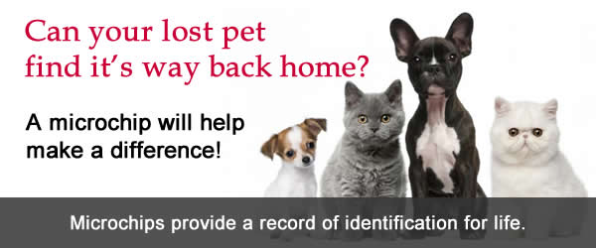

Each year, thousands of lost and abandoned animals are taken
some never make it back home because they can't be identified.
Collar tags can break or become unreadable and tattooing can become illegible. So, if you want to improve your pet's chances of getting home fast and safe in case it goes missing, microchipping is your best option.
Microchipping offers pet owners the security and peace of mind that comes from the only permanent pet identification technology and a safe and secure way to reunite you and your pet, via our Lost Pet Recovery Service.

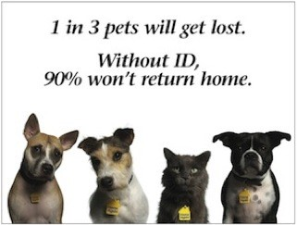
4 Reasons to Microchip Your Pet
- Permanent pet identification
- Best chance of recovering your pet
- Quick and painless procedure
- Lasts for your pet's lifetime

Wilbarger Humane Society will insert
a microchip in your Pet for $25.00.
Call for an appointment.

